Cabo Verde

## Population Data

The data set shows the political stability estimate of the country each year.

## # A tibble: 23 x 5  
## country iso3c date population popCategory5  
## <chr> <chr> <dbl> <dbl> <chr>   
## 1 Cabo Verde CPV 1996 395533 very small   
## 2 Cabo Verde CPV 1997 404259 very small   
## 3 Cabo Verde CPV 1998 412514 very small   
## 4 Cabo Verde CPV 1999 420452 very small   
## 5 Cabo Verde CPV 2000 428188 very small   
## 6 Cabo Verde CPV 2001 435709 very small   
## 7 Cabo Verde CPV 2002 442951 very small   
## 8 Cabo Verde CPV 2003 449930 very small   
## 9 Cabo Verde CPV 2004 456617 very small   
## 10 Cabo Verde CPV 2005 463032 very small   
## 11 Cabo Verde CPV 2006 469170 very small   
## 12 Cabo Verde CPV 2007 475060 very small   
## 13 Cabo Verde CPV 2008 480842 very small   
## 14 Cabo Verde CPV 2009 486671 very small   
## 15 Cabo Verde CPV 2010 492654 very small   
## 16 Cabo Verde CPV 2011 498856 very small   
## 17 Cabo Verde CPV 2012 505235 very small   
## 18 Cabo Verde CPV 2013 511748 very small   
## 19 Cabo Verde CPV 2014 518269 very small   
## 20 Cabo Verde CPV 2015 524743 very small   
## 21 Cabo Verde CPV 2016 531146 very small   
## 22 Cabo Verde CPV 2017 537497 very small   
## 23 Cabo Verde CPV 2018 543767 very small

## # A tibble: 23 x 5  
## country iso3c date popGrowth popGrowthCat5   
## <chr> <chr> <dbl> <dbl> <chr>   
## 1 Cabo Verde CPV 1996 2.37 moderate growth rate  
## 2 Cabo Verde CPV 1997 2.18 moderate growth rate  
## 3 Cabo Verde CPV 1998 2.02 moderate growth rate  
## 4 Cabo Verde CPV 1999 1.91 moderate growth rate  
## 5 Cabo Verde CPV 2000 1.82 moderate growth rate  
## 6 Cabo Verde CPV 2001 1.74 moderate growth rate  
## 7 Cabo Verde CPV 2002 1.65 moderate growth rate  
## 8 Cabo Verde CPV 2003 1.56 moderate growth rate  
## 9 Cabo Verde CPV 2004 1.48 slow growth rate   
## 10 Cabo Verde CPV 2005 1.40 slow growth rate   
## 11 Cabo Verde CPV 2006 1.32 slow growth rate   
## 12 Cabo Verde CPV 2007 1.25 slow growth rate   
## 13 Cabo Verde CPV 2008 1.21 slow growth rate   
## 14 Cabo Verde CPV 2009 1.20 slow growth rate   
## 15 Cabo Verde CPV 2010 1.22 slow growth rate   
## 16 Cabo Verde CPV 2011 1.25 slow growth rate   
## 17 Cabo Verde CPV 2012 1.27 slow growth rate   
## 18 Cabo Verde CPV 2013 1.28 slow growth rate   
## 19 Cabo Verde CPV 2014 1.27 slow growth rate   
## 20 Cabo Verde CPV 2015 1.24 slow growth rate   
## 21 Cabo Verde CPV 2016 1.21 slow growth rate   
## 22 Cabo Verde CPV 2017 1.19 slow growth rate   
## 23 Cabo Verde CPV 2018 1.16 slow growth rate

## Population trend

The plot shows the population trend of the country.

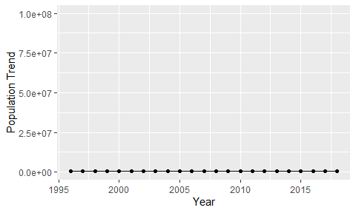

Political Stability Trend

# Population growth graph

The plot shows the population growth rate trend of the country.

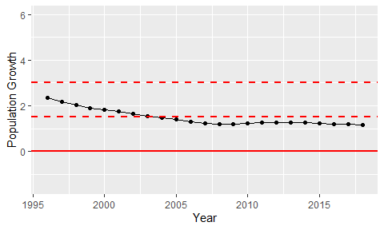

Population Growth Trend